The process to integrate new code with your language file in your system:

1. You have to configure the new front-end code on your system.
2. Steup all its environment.
3. Add the German language file to this new project and make all changes in the project to add the new german language. This is because we do not have the german language file, in the frontend but we have made all the changes in the backend for the german language also whatever frontend changes could be done, like adding the separate input fields for every language and saving it in the database have been implemented. You just have to add the german language file in the project in order to see the changes.
4. We have also made changes in the backend code, so in case you have established the backend code on your local system, you have to establish this new code. On the server, we have already kept the new and updated code.
5. Make sure to pass the German language code as “de”

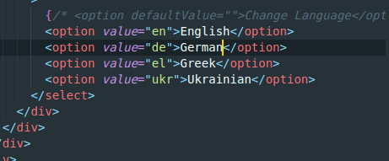

1. After you implement all the changes, you have to create a new build folder of the frontend code and then push the build folder on the server by making a zip of it and then unzip it on the server and move the content of the build folder in the root folder of the server.
2. If you face any problem while implementing this, please show us the screen recording of the issues.

Thank you!